**TWO:**

**1) Extract reviews of any product from ecommerce website like snapdeal and amazon**

**2) Perform sentimental analysis**

**Ans:**

> library(rvest)

> library(XML)

> library(magrittr)

> library(tm)

**Review extraction**

> url <- "https://www.amazon.in/OnePlus-McLaren-Limited-256GB-Storage/product-reviews/B07HGKGDHH/ref=cm_cr_dp_d_show_all_btm?ie=UTF8&reviewerType=all_reviews"

> McLaren <- NULL

> for(i in 1:10){

murl <- read_html(as.character(paste(url,i,sep = "=")))

rev <- murl%>%

html_nodes(".review-text")%>%

html_text()

McLaren <- c(McLaren,rev)

}

> write.table(McLaren,"McLaren.txt",row.names = F)

> oneplus7T <- unique(readLines("McLaren.txt"))

**Cleaning https://**

> df_oneplus7T <- gsub(pattern = "http.*",replacement = "",x=oneplus7T)

> df_oneplus7T <- gsub("http.","",df_oneplus7T)

> df_oneplus7T <- gsub("#.*","",df_oneplus7T)

> df_oneplus7T <- gsub("@.*","",df_oneplus7T)

> library(textcat)

> table(textcat(df_oneplus7T))

english middle_frisian norwegian ukrainian-koi8_r

9 1 1 1

> df_oneplus7T[which(textcat(df_oneplus7T)=="norwegian")]

[1] "\""

> consider <- c(which(textcat(df_oneplus7T)!="norwegian"))

> df_oneplus7T <- df_oneplus7T[consider]

**Stopwords**

> stop <- readLines(file.choose())

> McLaren_corp <- Corpus(VectorSource(df_oneplus7T))

> McLaren_corp <- tm_map(McLaren_corp,removePunctuation)

> McLaren_corp <- tm_map(McLaren_corp,removeWords,stop)

> McLaren_corp <- tm_map(McLaren_corp,stripWhitespace)

**TDM**

> McLaren_tdm <- TermDocumentMatrix(McLaren_corp)

**Convert tdm to dtm**

> McLaren_dtm <- t(McLaren_tdm)

> rowtotals <- apply(McLaren_dtm,1,sum)

> McLaren_dtm2 <- McLaren_dtm[rowtotals>3,]

> McLaren_dtm2$dimnames$Terms

[1] "30t" "90hz" "after"

[4] "all" "amazing" "ami"

[7] "and" "are" "backup"

[10] "battery" "beautiful" "beauty"

[13] "bed" "before" "best"

[16] "blazing" "booom4" "brightness"

[19] "but" "camera" "cameras"

[22] "can" "charger" "coming"

[25] "con" "days" "differences"

[28] "display" "displays" "displays2"

[31] "experience" "far" "fast5"

[34] "few" "find" "first"

[37] "for" "gestures" "getting"

[40] "good" "great" "guys"

[43] "had" "hand" "has"

[46] "have" "heavier" "iphone"

[49] "itgo" "its" "just"

[52] "less" "lightning" "lightweightthe"

[55] "lots" "makes" "might"

[58] "mobiles" "morning" "most"

[61] "night" "normal" "nothing"

[64] "now" "one" "oneplus"

[67] "only" "ordered" "oxygen"

[70] "perfect3" "performance" "photographer"

[73] "plus" "previous" "pro"

[76] "professional" "regret" "review"

[79] "s10" "samsung" "samsungs"

[82] "sharpness" "shortcuts" "side"

[85] "tell" "than" "that"

[88] "the" "there" "think"

[91] "this" "this1" "used"

[94] "user" "using" "usp"

[97] "very" "warp" "was"

[100] "weight" "when" "with"

[103] "wont" "write" "you"

[106] "0100" "1000" "1080p"

[109] "120" "22x" "2xl"

[112] "586" "60fps" "60hz"

[115] "640" "800" "855"

[118] "8gb" "a13" "admit"

[121] "adrena" "adreno" "afford"

[124] "almost" "also" "alternate"

[127] "although" "among" "android"

[130] "angle" "another" "any"

[133] "app" "apple" "aspects"

[136] "asus" "available" "average"

[139] "back" "bang" "been"

[142] "being" "believe" "below"

[145] "belowoneplus" "benchmark" "better"

[148] "bigger" "biggest" "bionic"

[151] "bit" "box" "boxif"

[154] "brand" "bricktype" "brighter"

[157] "brutally" "buckif" "build"

[160] "business" "butter" "button"

[163] "cableand" "cannot" "case"

[166] "casesim" "charge" "charging"

[169] "click" "closely" "cod"

[172] "combined" "community" "compared"

[175] "conditions" "consumers" "cool"

[178] "corners" "couldve" "cpus"

[181] "curved" "curves" "customized"

[184] "day" "design" "developers"

[187] "device" "devices" "deviceuser"

[190] "different" "disappointed" "distortions"

[193] "doesnt" "dont" "doubt"

[196] "down" "drops" "due"

[199] "edges" "edition" "eis"

[202] "ejector" "elements" "episode"

[205] "essential" "eventually" "everyday"

[208] "expecting" "experienced" "extra"

[211] "fairly" "fan" "fans"

[214] "fast" "faster" "fastest"

[217] "features" "feel" "feels"

[220] "filmic" "firstly" "fixed"

[223] "flagships" "fluid" "frames"

[226] "from" "future" "galaxy"

[229] "gaming" "gcam" "get"

[232] "gets" "gig" "gimbal"

[235] "glares" "google" "hands"

[238] "haptic" "havent" "hear"

[241] "heavy" "helps" "hence"

[244] "here" "hold" "honest"

[247] "honestly" "hooked" "however"

[250] "imagined" "improved" "improvements"

[253] "imx" "include" "included"

[256] "incremental" "indeed" "industry"

[259] "into" "isnt" "juices"

[262] "knit" "known" "lacked"

[265] "lacks" "lead" "league"

[268] "leap" "lengthy" "lesser"

[271] "lighting" "like" "longer"

[274] "look" "lossless" "lot"

[277] "luxurious" "macro" "made"

[280] "main" "majorly" "management"

[283] "manualtransparent" "marginally" "mclaren"

[286] "mention" "minor" "missed"

[289] "mobile" "mod" "mode"

[292] "modes" "more" "motor"

[295] "much" "multitasking" "navigational"

[298] "negligible" "netflix" "never"

[301] "nevertheless" "nightscape" "nits"

[304] "nonotch" "nor" "not"

[307] "notches" "note" "off"

[310] "ois" "okayish" "old"

[313] "once" "optical" "other"

[316] "otherwise" "out" "over"

[319] "oversaturated" "own" "par"

[322] "party" "patches" "personally"

[325] "phone" "photography" "pixel"

[328] "plan" "planning" "predecessor"

[331] "predecessors" "prefer" "premium"

[334] "present" "presently" "processor"

[337] "producers" "profession" "professionals"

[340] "proof" "pros" "provide"

[343] "pubg" "purchasing" "quality"

[346] "ram" "rating" "read"

[349] "reading" "recommend" "recommended"

[352] "recording" "regular" "require"

[355] "rog" "rolling" "rounder"

[358] "rupee" "same" "save"

[361] "say" "screen" "screenshots"

[364] "seconds" "security" "seems"

[367] "selfies" "sensor" "series"

[370] "set" "shake" "shoot"

[373] "shooting" "shots" "should"

[376] "shutter" "silence" "silicon"

[379] "simple" "slippery" "smaller"

[382] "smoooooth" "smooth" "snapdragon"

[385] "software" "some" "sony"

[388] "specialist" "splash" "splendid"

[391] "stickers" "still" "stock"

[394] "stunning" "suggestion" "super"

[397] "switch" "t30" "take"

[400] "takes" "technology" "telephoto"

[403] "their" "then" "these"

[406] "they" "third" "through"

[409] "time" "tof" "together"

[412] "too" "toolwarp" "transitioning"

[415] "turn" "unless" "upcoming"

[418] "updated" "updates" "upgrade"

[421] "upgrades" "upto" "usage"

[424] "usb" "uses" "utilizing"

[427] "value" "verdict" "versions"

[430] "video" "videos" "want"

[433] "warping" "well" "what"

[436] "whats" "which" "while"

[439] "wide" "will" "wireless"

[442] "wish" "without" "worth"

[445] "worthy" "would" "writing"

[448] "years" "your" "youre"

[451] "advertisedno" "apps" "between"

[454] "camerathere" "complaints" "die"

[457] "duty" "ever" "experiencecall"

[460] "flawlessly" "formagnificent" "functionsthe"

[463] "hiccups" "itoverall" "none"

[466] "overall" "overwhelming" "runs"

[469] "speed" "switching" "tocharging"

[472] "wrong" "5399900" "5400000"

[475] "about" "amazon" "awaited"

[478] "back1st" "camerathe" "captured"

[481] "colorthere" "compromise" "dear"

[484] "dots" "draw" "feedback"

[487] "give" "his" "image"

[490] "issue" "issues" "major"

[493] "maker" "next" "open"

[496] "original" "paid" "pass"

[499] "pic" "pictures" "poor"

[502] "poorin" "qualityhope" "qualityso"

[505] "ripupduring" "ripupimage" "saw"

[508] "see" "shot" "solve"

[511] "team" "todays" "updatesdear"

[514] "users" "why" "work"

[517] "zoom" "zoomnight" "superb"

[520] "u0001f44du0001f3fb" "5tyou" "7pro"

[523] "admiring" "again" "always"

[526] "anytime" "area" "awesome"

[529] "batter" "betterbright" "big"

[532] "bright" "bumpand" "cameraselfies"

[535] "camerasi" "cant" "circular"

[538] "claiming6" "clear" "clearly"

[541] "clicks" "close" "closeup"

[544] "cms" "combination" "come"

[547] "controlled" "crisp" "dayeven"

[550] "displayi" "displays5build" "doubtful"

[553] "dslr" "easily" "edge"

[556] "effectonce" "enoughthis" "everyone"

[559] "exactly" "excellent" "felt"

[562] "flowers" "gives" "hardware"

[565] "hated" "hesitant" "huge"

[568] "it2excellent" "ive" "killed"

[571] "kinds" "lasts" "later3dolby"

[574] "love" "loved" "mark"

[577] "mobileit" "model" "models490"

[580] "muchwill" "neat" "new"

[583] "noisethe" "notice" "older"

[586] "osbut" "patterns" "perfect"

[589] "perfectits" "popup" "portrait"

[592] "prothis" "quick" "rate"

[595] "really" "refresh" "setup"

[598] "sharp" "sleekstylish" "soo"

[601] "sound" "speakers" "stereo"

[604] "stop" "taking" "telling"

[607] "thisyou" "thoughthighlights1buttery" "totally"

[610] "unbelievably" "unwanted" "update"

[613] "usual" "vivid" "wasnt"

[616] "whole" "worryit" "wowlooks"

[619] "wowwww" "yes" "acko"

[622] "anyone" "didnt" "everything"

[625] "goodbut" "got" "offerdo"

[628] "protection" "yearbut" "able"

[631] "action" "anything" "butafter"

[634] "check" "continuously" "conversation"

[637] "done" "drained" "games"

[640] "handicapped" "happy" "hours"

[643] "itself" "long" "maybe"

[646] "navigation" "perform" "playing"

[649] "power" "problem" "random"

[652] "reboot" "rebooted" "rebooting"

[655] "returning" "risk" "shocked"

[658] "silk" "started" "support"

[661] "teambuy" "thought" "till"

[664] "videofinally" "were" "where"

[667] "fanatic" "shown" "100"

[670] "a355ranjan" "already" "apppros"

[673] "assume" "best6" "bug"

[676] "bugs" "buy" "call"

[679] "came" "camera2" "case5"

[682] "charging3" "cheers" "comes"

[685] "compromising" "cons" "darker"

[688] "definitely" "drains" "else"

[691] "found" "frozen3" "ghosh"

[694] "going" "grip4" "guard5"

[697] "handset" "hard" "heats"

[700] "helped" "hope" "hoping"

[703] "hung" "internet" "keeps"

[706] "menu" "need" "on4"

[709] "package" "people" "performancei"

[712] "ppl" "properly" "quickly2"

[715] "removed" "reviews" "ron"

[718] "rubbery" "simultaneous" "slept"

[721] "sounds" "surf" "trying"

[724] "unable" "use" "wait"

[727] "whatsapp" "wifi" "woth"

**LDA**

> library(topicmodels)

> McLaren_LDA <- LDA(x=McLaren_dtm2,10)

> McLaren_LDA_terms <- terms(McLaren_LDA,5)

> McLaren_LDA_terms

Topic 1 Topic 2 Topic 3 Topic 4 Topic 5 Topic 6 Topic 7 Topic 8 Topic 9 Topic 10

[1,] "and" "the" "the" "one" "and" "and" "the" "the" "the" "its"

[2,] "one" "and" "for" "phone" "the" "mode" "and" "its" "this" "the"

[3,] "plus" "oneplus" "and" "screen" "just" "phone" "for" "out" "for" "and"

[4,] "the" "pro" "very" "amazon" "oneplus" "ever" "was" "would" "with" "one"

[5,] "this" "you" "this" "acko" "you" "are" "after" "for" "pro" "for"

> topics <- terms(McLaren_LDA)

> table <- table(names(topics),unlist(topics))

> library(cluster)

> library(dendextend)

> cluster <- hclust(dist(table),method = "ward.D2")

> colr <- color_branches(cluster,k=4)

> plot(colr)

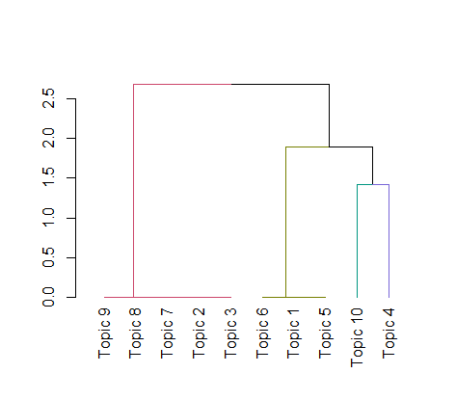

**NLP**

> library(syuzhet)

> McLarens <- get_sentences(df_oneplus7T)

> class(McLarens)

[1] "character"

**Sentiment analysis**

> sentiments <- c("syuzhet","afinn","bing","nrc","custom")

> A <- NULL

> sentimentlist <- NULL

> for(i in sentiments[1:4]){

sentimentlist[[i]] <- get_sentiment(McLarens,method = i)

A[[i]] <- table(get_sentiment(McLarens,method = i))

}

> A

$syuzhet

-1.35 -1 -0.9 -0.8 -0.75 -0.6 -0.55 -0.5 -0.25 -0.1 0 0.1 0.15 0.25 0.3

1 1 1 1 7 2 1 4 4 2 34 2 2 2 1

0.4 0.5 0.55 0.6 0.75 0.8 0.9 1 1.1 1.15 1.2 1.25 1.3 1.4 1.45

3 15 1 8 14 5 1 4 2 1 3 1 3 1 1

1.5 1.6 1.7 1.8 1.95 2.05 2.1 2.15 2.25 3.25 3.65 4.15

1 3 1 1 2 1 1 1 1 1 1 1

$afinn

-3 -2 -1 0 1 2 3 4 5 6 7 9 10

4 5 5 67 6 19 16 7 5 4 3 1 1

$bing

-3 -2 -1 0 1 2 3 4 5

1 2 18 51 51 13 3 2 2

$nrc

-2 -1 0 1 2 4

5 15 78 36 8 1

> sentimentlist

$syuzhet

[1] 0.00 0.50 0.00 0.50 1.25 0.50 0.00 0.80 0.75 0.75 0.00 -0.25 0.15 0.00

[15] 0.50 0.00 -0.25 0.00 0.00 -0.75 -0.50 0.75 0.25 0.75 0.75 0.60 0.00 1.20

[29] 0.00 2.10 0.80 0.00 0.00 -0.25 0.00 -0.25 0.00 1.50 0.10 0.75 0.40 0.50

[43] -0.80 0.00 1.15 1.10 0.00 0.60 3.25 0.40 0.75 0.75 0.30 -0.50 0.25 0.00

[57] 0.00 -0.10 0.10 1.00 1.00 0.55 4.15 1.45 1.40 0.75 0.80 1.00 1.70 0.50

[71] 1.20 0.00 0.60 -0.75 0.50 -0.75 -0.60 0.60 0.00 0.00 -1.00 0.15 2.05 0.50

[85] 0.50 1.80 1.10 0.75 1.20 2.15 1.30 0.50 0.75 0.50 0.00 0.60 0.00 -1.35

[99] -0.75 0.60 0.80 0.50 0.00 1.60 1.60 3.65 1.60 0.00 0.50 1.95 0.50 0.75

[113] -0.75 0.80 0.90 0.00 0.75 1.95 0.00 0.75 0.00 -0.50 -0.90 -0.55 0.50 -0.75

[127] -0.50 1.30 0.60 0.00 -0.75 -0.10 2.25 0.40 1.30 0.00 1.00 0.00 -0.60 0.00

[141] 0.00 0.60 0.00

$afinn

[1] 0 0 0 4 4 3 0 0 3 3 0 0 0 0 3 0 0 0 0 -2 2 2 0 2 2 0 0 2

[29] 0 5 0 0 0 0 0 0 0 5 3 0 0 2 0 0 4 3 0 0 10 0 2 0 1 -1 0 0

[57] 0 2 0 0 6 2 3 5 0 2 1 5 1 3 0 -1 0 -3 0 -2 0 0 0 0 -1 -1 6 2

[85] 3 7 4 7 -2 5 4 2 3 4 1 1 0 -3 -3 0 2 1 0 7 2 6 0 0 3 6 3 3

[113] -1 0 0 0 3 3 0 3 0 -2 -3 0 2 -2 0 4 0 0 0 0 9 0 2 0 2 0 2 0

[141] 0 2 0

$bing

[1] 0 1 0 1 1 1 0 0 1 1 0 -1 1 0 1 0 0 0 0 -1 -1 1 0 1 1 1 0 1

[29] 1 2 1 0 0 1 0 -1 0 2 1 1 0 1 0 0 1 2 0 0 3 0 1 1 0 0 1 0

[57] 0 1 0 0 2 0 5 1 0 1 0 2 2 1 1 0 1 -1 1 -1 -1 1 1 0 -1 0 -2 0

[85] 1 2 2 2 2 3 1 1 1 1 0 1 0 -2 -1 1 1 2 0 2 1 5 2 -1 1 4 1 1

[113] -1 1 1 0 1 3 0 1 0 -1 -1 -1 1 -1 -1 1 0 0 -3 -1 4 0 1 0 0 0 0 0

[141] -1 0 0

$nrc

[1] 0 1 0 0 2 0 0 1 1 0 0 0 0 0 0 0 0 0 0 -1 1 1 0 1 1 0 0 0

[29] 0 1 0 0 0 -1 0 -1 0 1 1 1 0 0 0 0 1 0 0 1 2 1 1 2 -1 -1 1 0

[57] 0 -1 0 1 -2 -1 2 2 2 0 0 0 2 0 1 0 0 -1 1 -1 1 0 0 0 0 1 2 1

[85] 0 1 1 1 1 1 0 0 1 0 0 -2 0 -1 -1 0 0 0 0 1 0 4 0 0 0 0 0 1

[113] -1 0 1 0 1 0 0 1 0 0 -1 1 0 -1 -1 0 1 0 -2 -2 0 0 1 0 0 0 -2 0

[141] 0 0 0

**Plot for NRC**

> plot(sentimentlist$nrc,type = "l",main = "NRC plot")

> abline(h=0,col ="red")

> abline(h=1,col ="blue")

> abline(h=2,col="yellow")

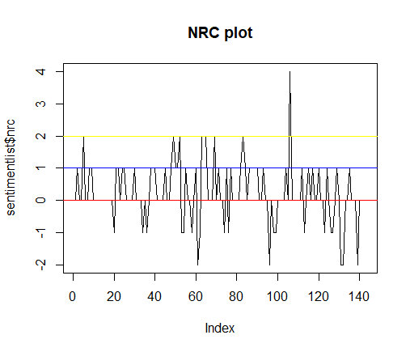

**Sentences with negative emotion values**

> negative <- sentimentlist$nrc[which.min(sentimentlist$nrc)]

> McLarens[which(sentimentlist$nrc==negative)]

[1] "Oxygen OS has presently the best OS Experience for Android.==== Battery ====Warp T30 is super fast."

[2] "You get crisp and clear pictures without any noise."

[3] "Cons :1) Heats up quickly2) If on a video call ( whatsapp) unable to use whatsapp properly getting hung it screen frozen3) Battery drains out a bit fast."

[4] "In 15 hours battery came from 100% to 35 % off which I slept for 8 hours with Wi-Fi and internet on.4) The set is very slippery, you will need a case.5) I assume there is a bug which keeps going to the main menu when I'm trying to surf any app."

[5] "Or you can just wait for the Mclaren edition of you like a darker and more Ram speed."

**Sentences with positive emotions values**

> positive <- sentimentlist$nrc[which.max(sentimentlist$nrc)]

> McLarens[which(sentimentlist$nrc==positive)]

[1] "It is clearly faster and better than the usual 60Hz displays.5)Build and design - Just perfect...It's sleek..."

**Emotion plot**

> nrc_data <- get_nrc_sentiment(McLarens)

> barplot(sort(colSums(prop.table(nrc_data[,1:8]))),cex.names = 0.8,col = 1:8)

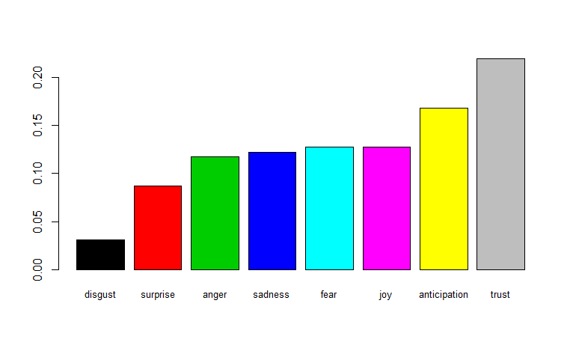

**word cloud**

> library(tm)

> library(SnowballC)

> library(wordcloud)

> library(RColorBrewer)

> freq <- rowSums(as.matrix(McLaren_tdm))

> length(freq)

[1] 729

> order <- order(freq,decreasing = TRUE)

> head(freq)

30t 90hz after all amazing ami

3 3 5 3 5 1

> data_frame <- data.frame(word=names(freq),freq=freq)

> data_frame <- data_frame[-8,]

> windows()

> wordcloud(words = data_frame$word,freq = data_frame$freq,min.freq = 2,max.words = 200,random.order = F,colors = brewer.pal(10,"Dark2"))

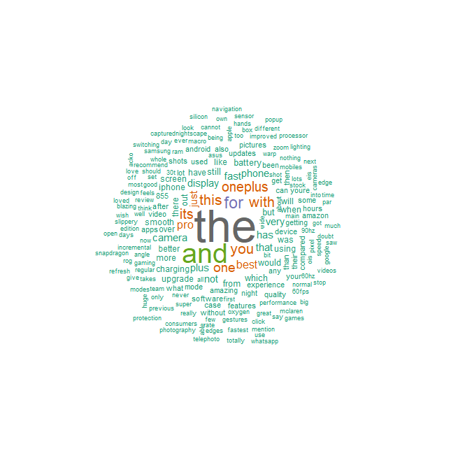

> findFreqTerms(McLaren_dtm,lowfreq = 5)

[1] "after" "amazing" "and" "are" "battery" "best"

[7] "but" "camera" "can" "display" "experience" "for"

[13] "getting" "has" "have" "iphone" "its" "just"

[19] "one" "oneplus" "plus" "pro" "than" "that"

[25] "the" "there" "this" "used" "using" "very"

[31] "was" "when" "with" "you" "any" "better"

[37] "charging" "device" "fast" "from" "get" "like"

[43] "lot" "mode" "more" "not" "out" "over"

[49] "phone" "screen" "smooth" "software" "still" "updates"

[55] "upgrade" "video" "which" "will" "would"

> findAssocs(McLaren_dtm,terms = "fast",corlimit = 0.3)

$fast

without bit day edition hands

0.87 0.85 0.85 0.85 0.85

like mclaren more off once

0.85 0.85 0.85 0.85 0.85

processor say get will video

0.85 0.85 0.84 0.84 0.83

but with the being ram

0.82 0.80 0.79 0.79 0.79

set slippery can there this

0.79 0.79 0.77 0.77 0.77

some what display case their

0.77 0.77 0.74 0.74 0.74

for which would experience has

0.72 0.72 0.72 0.70 0.70

oneplus out that very and

0.70 0.70 0.69 0.69 0.67

charging nightscape not pixel upgrade

0.67 0.67 0.67 0.67 0.67

well you from any compared

0.67 0.66 0.66 0.65 0.65

60hz been click design different

0.64 0.64 0.64 0.64 0.64

fan faster havent lighting mobile

0.64 0.64 0.64 0.64 0.64

modes new update battery over

0.64 0.64 0.64 0.63 0.63

smooth using pro better than

0.61 0.59 0.58 0.58 0.57

0100 1000 1080p 120 22x

0.57 0.57 0.57 0.57 0.57

2xl 586 60fps 640 800

0.57 0.57 0.57 0.57 0.57

855 8gb a13 admit adrena

0.57 0.57 0.57 0.57 0.57

adreno afford almost alternate although

0.57 0.57 0.57 0.57 0.57

among angle another app aspects

0.57 0.57 0.57 0.57 0.57

asus available average back bang

0.57 0.57 0.57 0.57 0.57

believe below belowoneplus benchmark bigger

0.57 0.57 0.57 0.57 0.57

biggest bionic box boxif brand

0.57 0.57 0.57 0.57 0.57

bricktype brighter brutally buckif build

0.57 0.57 0.57 0.57 0.57

business butter button cableand casesim

0.57 0.57 0.57 0.57 0.57

charge closely cod combined community

0.57 0.57 0.57 0.57 0.57

conditions consumers cool corners couldve

0.57 0.57 0.57 0.57 0.57

cpus curved curves customized developers

0.57 0.57 0.57 0.57 0.57

devices deviceuser disappointed distortions doesnt

0.57 0.57 0.57 0.57 0.57

dont down drops due edges

0.57 0.57 0.57 0.57 0.57

eis ejector elements episode essential

0.57 0.57 0.57 0.57 0.57

eventually everyday expecting extra fairly

0.57 0.57 0.57 0.57 0.57

fans feel feels filmic firstly

0.57 0.57 0.57 0.57 0.57

fixed flagships fluid frames future

0.57 0.57 0.57 0.57 0.57

galaxy gaming gcam gets gig

0.57 0.57 0.57 0.57 0.57

gimbal glares google haptic hear

0.57 0.57 0.57 0.57 0.57

heavy helps hence here hold

0.57 0.57 0.57 0.57 0.57

honest honestly hooked however imagined

0.57 0.57 0.57 0.57 0.57

improved improvements imx include included

0.57 0.57 0.57 0.57 0.57

incremental indeed industry into isnt

0.57 0.57 0.57 0.57 0.57

juices knit known lacked lacks

0.57 0.57 0.57 0.57 0.57

lead league leap lengthy lesser

0.57 0.57 0.57 0.57 0.57

longer lossless lot luxurious macro

0.57 0.57 0.57 0.57 0.57

main majorly management manualtransparent marginally

0.57 0.57 0.57 0.57 0.57

minor missed mod motor much

0.57 0.57 0.57 0.57 0.57

multitasking navigational negligible netflix nevertheless

0.57 0.57 0.57 0.57 0.57

nits nonotch nor notches note

0.57 0.57 0.57 0.57 0.57

ois okayish old optical other

0.57 0.57 0.57 0.57 0.57

otherwise oversaturated par party patches

0.57 0.57 0.57 0.57 0.57

personally plan planning predecessor predecessors

0.57 0.57 0.57 0.57 0.57

prefer premium present presently producers

0.57 0.57 0.57 0.57 0.57

profession professionals proof pros provide

0.57 0.57 0.57 0.57 0.57

pubg purchasing rating read reading

0.57 0.57 0.57 0.57 0.57

recommend recommended recording require rog

0.57 0.57 0.57 0.57 0.57

rolling rounder rupee same save

0.57 0.57 0.57 0.57 0.57

screenshots seconds security seems selfies

0.57 0.57 0.57 0.57 0.57

sensor series shake shoot shooting

0.57 0.57 0.57 0.57 0.57

should shutter silence silicon simple

0.57 0.57 0.57 0.57 0.57

smaller smoooooth snapdragon sony specialist

0.57 0.57 0.57 0.57 0.57

splash splendid stickers still stock

0.57 0.57 0.57 0.57 0.57

stunning suggestion switch t30 take

0.57 0.57 0.57 0.57 0.57

technology telephoto these they third

0.57 0.57 0.57 0.57 0.57

through time tof together toolwarp

0.57 0.57 0.57 0.57 0.57

transitioning turn unless upcoming updated

0.57 0.57 0.57 0.57 0.57

updates upgrades upto usb uses

0.57 0.57 0.57 0.57 0.57

utilizing value verdict versions videos

0.57 0.57 0.57 0.57 0.57

want warping whats while wide

0.57 0.57 0.57 0.57 0.57

wireless wish worth worthy writing

0.57 0.57 0.57 0.57 0.57

years youre whole 100 a355ranjan

0.57 0.57 0.57 0.57 0.57

already apppros assume best6 bug

0.57 0.57 0.57 0.57 0.57

bugs buy call came camera2

0.57 0.57 0.57 0.57 0.57

case5 charging3 cheers comes compromising

0.57 0.57 0.57 0.57 0.57

cons darker definitely drains else

0.57 0.57 0.57 0.57 0.57

found frozen3 ghosh going grip4

0.57 0.57 0.57 0.57 0.57

guard5 handset hard heats helped

0.57 0.57 0.57 0.57 0.57

hope hoping hung internet keeps

0.57 0.57 0.57 0.57 0.57

menu need on4 package people

0.57 0.57 0.57 0.57 0.57

performancei ppl properly quickly2 removed

0.57 0.57 0.57 0.57 0.57

reviews ron rubbery simultaneous slept

0.57 0.57 0.57 0.57 0.57

sounds surf trying unable use

0.57 0.57 0.57 0.57 0.57

wait whatsapp wifi woth android

0.57 0.57 0.57 0.57 0.56

amazing apple device never regular

0.54 0.54 0.54 0.54 0.54

super takes speed best features

0.54 0.54 0.54 0.53 0.53

> head(data_frame,10)

word freq

30t 30t 3

90hz 90hz 3

after after 5

all all 3

amazing amazing 5

ami ami 1

and and 51

backup backup 1

battery battery 8

beautiful beautiful 1

> barplot(data_frame[(1:11),]$freq,names.arg = data_frame[(1:11),]$word,col = "navyblue")

